Metaheuristic optimization
Guilherme Rossetti Lima

NP-Completeness
- SAT to 3SAT:

F= (p1)∧(¬p1∨ p2∨ ¬p3∨ ¬p4 ∨ p5)

- Clause 1 conversion to 3SAT:

C1 = (P1 V V )
C2 = (P1 V ¬ V)
C3 = (P1 V V ¬)
C4 = (P1 V ¬ V ¬)

(p1) = (P1 V V ) ∧ (P1 V ¬ V) ∧ (P1 V V ¬) ∧ (P1 V ¬ V ¬)

- Clause 2 conversion to 3SAT:

C1: (¬P1 V P2 V )
C2: (¬V ¬P3 V )
C3: (¬V ¬P4 V ¬P5)

(¬p1∨ p2∨ ¬p3∨ ¬p4 ∨ p5) = (¬P1 V P2 V ) ∧ (¬V ¬P3 V ) ∧ (¬V ¬P4 V ¬P5)

- Final 3SAT Formula:

(P1 V V ) ∧ (P1 V ¬ V) ∧ (P1 V V ¬) ∧ (P1 V ¬ V ¬) ∧ (¬P1 V P2 V ) ∧ (¬V ¬P3 V ) ∧ (¬V ¬P4 V ¬P5)

- Satisfiability:
Follow a table with a solution for the 3SAT Clause.
P1 | P2 | P3 | P4 | P5 | U1,1 | U1,2 | U2,1 | U2,2 | C1 | C2 | C3 | C4 | C5 | C6 | C7
TRUE | TRUE | FALSE | FALSE | FALSE | FALSE | FALSE | FALSE | FALSE | TRUE | TRUE | TRUE | TRUE | TRUE | TRUE | TRUE

Clause | Satisfied by
(P1 V V ) | P1
(P1 V ¬ V) | P1 and ¬
(P1 V V ¬) | P1 and ¬
(P1 V ¬ V ¬) | P1,¬ and ¬
(¬P1 V P2 V ) | P2
(¬V ¬P3 V ) | ¬¬P3
(¬V ¬P4 V ¬P5) | ¬¬P4 and ¬P5

The same solution applies to the original SAT problem since P1 will satisfy the first clause and P2 the second, following a table showing the satisfiability.

P1 | P2 | P3 | P4 | P5 | C1 | C2
TRUE | TRUE | FALSE | FALSE | FALSE | TRUE | TRUE

Clause | Satisfied by
(P1) | P1
(¬p1∨ p2∨ ¬p3∨ ¬p4 ∨ p5) | P1 and ¬

- SAT to 3SAT:
Convert the second and fifth clauses from the 3SAT solution to 3COL.
(P1 V ¬ V ) ∧ (¬P1 V P2 V )

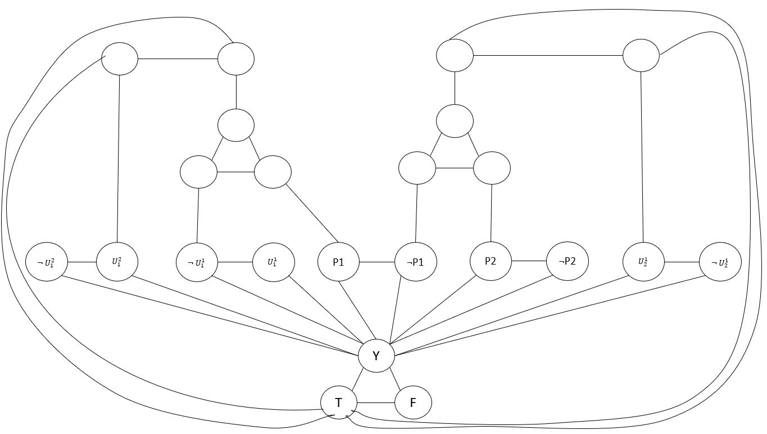

Genetic algorithms evaluation

Introduction:
This report presents the results of a series of experiments to measure the performance and suitability of genetic algorithms for the travel salesman problem. We start by showing the impacts of two different initialization methods and then walk through the effects of crossover, mutation, elitism and population size on the quality of results and runtime.
It is essential to highlight that genetic algorithms are highly dependent on the values of the hyperparameters and that the quality of the results obtained is directly correlated to the selection of the correct values, which is an empiric process based on experimentation demonstrated throughout this report.
- Impacts of initialization method:
Two different heuristics were used to initialize the population for the experiments, nearest neighbour insertion and random insertion. Both will generate valid tours for the TSP problem, but each has its advantages and disadvantages. The following table depicts the best initial item resulting from each heuristic type, along with the average for the ten runs.

Run | Best initial for nearest neighbour insertion | Best initial for random
1 | 13005325.84 | 348138189.4
2 | 12944719.93 | 343786798
3 | 13040662.48 | 349719254.1
4 | 12892859.59 | 347092658.5
5 | 12890328.34 | 345877766.4
6 | 12920175.92 | 348372170
7 | 12890328.34 | 348954146.6
8 | 12892859.59 | 343995161.1
9 | 12890328.34 | 348301909.1
10 | 12942802.15 | 347503781.7
Average | 12931039.05 | 347174183.5
Table 1.0 generated based on a run with inst-6.tsp

Table 1.0 shows that the random heuristic will generate more extended tours, in this case, 26 times longer than nearest neighbours. The first city in the tour is selected randomly. The next picked will always be the nearest city for insertion (Euclidian distance), generating a shorter tour. Even though the NN insertion heuristic results in good tours, it has an extra cost in terms of performance since we will have to go through each city (N-1) times and calculate its distance in turn for each insertion until the unvisited list is empty.
Note: N is the total number of cities unvisited in our case; the runtime cost will be directly proportional to the value of N.
The following are the results from an evaluation with genetic algorithms for both initialization methods, where the runtime cost does not include the cost discussed before for initialization.

Run | Runtime cost nearest neighbour initialization (seconds) | Runtime cost for random initialization (seconds)
1 | 39.741198 | 0.175531
2 | 37.895095 | 0.131647
3 | 40.412335 | 0.133642
4 | 40.124905 | 0.141621
5 | 40.968271 | 0.178522
6 | 42.512506 | 0.134642
7 | 41.030389 | 0.128656
8 | 40.573231 | 0.147606
9 | 39.852484 | 0.132644
10 | 40.745962 | 0.144613
Average | 40.3856376 | 0.1449124
Table 1.1 generated from a run with inst-6.tsp where N is equal to 823
Nearest neighbour insertion:
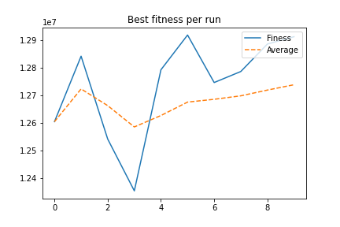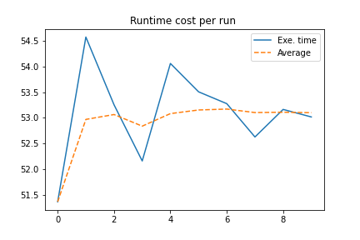
Image 1.0 run with inst-6 NN Initialization fitness Image 1.1 run with inst-6 NN Initialization runtime cost

Random insertion:
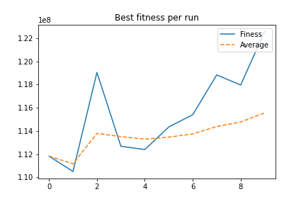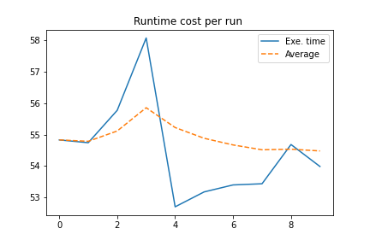
Image 1.2 run with inst-6 Randon init. Fitness Image 1.3 run with an inst-6 random init. runtime cost

As we can see, the runtime method for the GA evaluation is very similar, only with a couple of seconds difference between the average for both experiments. In terms of fitness, the results for NN insertion are better than the random insertion, which is down to the strength of the first generation created by the NN insertion, as we mentioned before. However, it is noticeable that it finds more results when searching with the GA random insertion than its counterpart. By fine-tuning the hyperparameters, it is possible to make random get close to the results generated by NN; however, it would come with an extra computational cost, and the time required would be higher than only applying NN for initialization.
The below images depicts the best individual per generation for each initialization method.

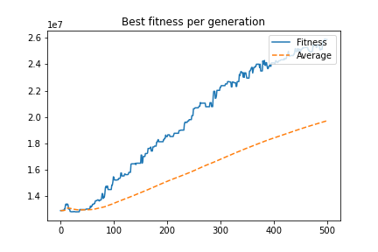
Image 1.4 nearest neighbour insertion for inst-6.tsp with 500 iterations.

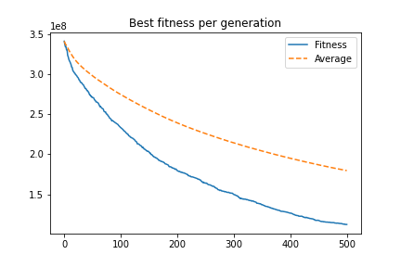
Image 1.5 random insertion for inst-6.tsp with 500 iterations without elite

Image 1.4 shows that in the first 50 generations, the experiment initialized with the nearest neighbour can find better solutions in its surrounds on the search space. Still, then it converges, and none of the future generations finds a better solution. This early convergence is a side effect of the first generation’s strength and the hyperparameter configurations such as population size and the lack of diversity in the population, which is a common cause for premature conversion to local optima. In the following sections of this report, we will show how tweaking the parameters can help the GA mitigate this early convergence.
Image 1.5 presents the best fitness per generation for the random initialization, where we cannot see the same trend from the previous image. As we are initializing it randomly, there is more diversity in the population.
Note that I am using elitism 10% for the runs; hence, even though every individual in the new populations generated is worst than its previous one, there are still 10% survivors from the past generation not shown in the image x.y. The purpose is to depict the quality of children generated per generation without considering the elite.
The table below provides details for the parameters used to run the experiments in the comparisons presented here.
File | Crossover probability | Mutation probability | Iterations | Population size | Elitism | initialization
inst-6.tsp | 0.8 | 0.05 | 500 | 100 | 0.1 | 1
inst-6.tsp | 0.8 | 0.05 | 500 | 100 | 0.1 | 0
Table 1.2 – parameters for experiments ran
- Crossover impact in the results:
Crossover is an important step in a genetic algorithm as it will generate the children that populate the new generations based on specific characteristics from the parent’s chromosomes picked at random from each parent, in the case of the TSP problem that will promote a combination of paths that can result in better solutions. The experiments reported here are using truncation selection which will only allow the 25% fitter individuals in each generation to make it to the mating pool to be selected for crossover.
Diversity is an important point for crossover since the crossover for two similar individuals will not generate children with different characteristics; crossover also contributes to diversity by generating different individuals.
The crossover probability is hyperparameter responsible for the crossover that will take place in each run, lower probabilities will generate fewer children per generation, and higher probabilities do the inverse. This report applies tests for three different crossover probabilities, 5%, 30%, and 80%.

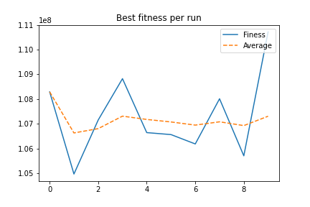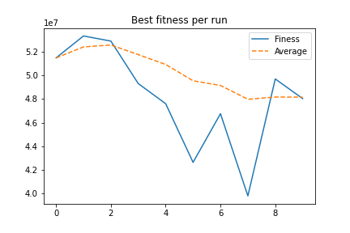
Image 2.0Image Inst-16 run with 5% crossover Image2.1 Inst-16 run with 30% crossover
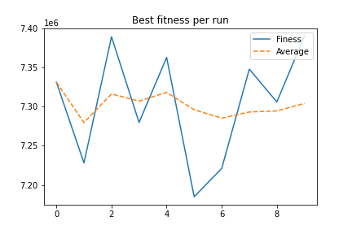
Image 2.2 Inst-16 with 80% crossover
Run | Best solution for 5% crossover | Iteration found for 5% | Best solution for 30% crossover |  | Iteration found for 30% | Best solution for 80% crossover | Iteration found 80%
1 | 108289724.8 | 4 | 51466584.75 | 199 |  | 20664754.71 | 499
2 | 104967945.8 | 44 | 53320715.39 | 500 |  | 20363981.94 | 498
3 | 107152363.8 | 17 | 52886868.45 | 246 |  | 19279645.57 | 495
4 | 108823613.9 | 126 | 49295862.46 | 339 |  | 20559318.39 | 500
5 | 106642339.6 | 58 | 47598123.07 | 203 |  | 19809417.39 | 500
6 | 106562684.1 | 320 | 42640353.62 | 435 |  | 20331917.89 | 498
7 | 106184203.6 | 213 | 46751061.03 | 458 |  | 20257172.64 | 500
8 | 108010829.2 | 322 | 39806829.29 | 345 |  | 19918054.01 | 500
9 | 105704017.6 | 492 | 49687173.96 | 184 |  | 20502764.06 | 498
10 | 110713329.8 | 2 | 48026539.68 | 402 |  | 19983831.16 | 499
Avg. | 107305105.2 | 159.8 | 48148011.17 | 331.1 |  | 20167085.78 | 498.7

Table 2.0 – Best solutions and iterations it was found for different parameter

The images and table above show how the solution improves as we increase the crossover probability, which is because of the higher crossover probability rates that will lead to a higher number of combinations attempts between the fittest parents, increasing the chance of finding an offspring that is even fittest than its parent and increasing diversity as well which is essential to avoid early convergence.

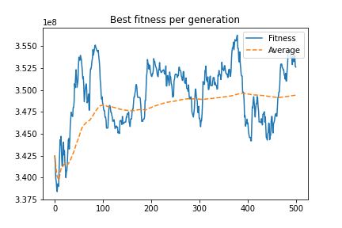
Image 2.3 best children fitness per generation for 5% Pc inst-16
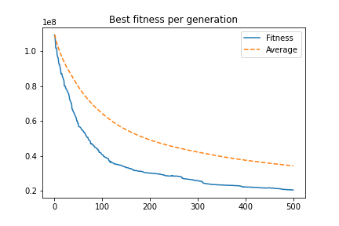
Image 2.4 best children fitness per generation for 80% Pc inst-16

Image 2.3 shows the behaviour mentioned before where the GA converges prematurely due to the low variance in the generations; there is still some crossover happening, which creates the slight variance along with mutation. A lucky mutation or crossover could generate a better solution, but the chances are lower as both hyperparameter probabilities are low. Image 2.4 shows that higher crossover probabilities consistently generate better children across generations.
The previous experiments were run using random initialization; in the following images, we can see the same trends for NN initialization but on a lower scale due to the reasons explained in the impact of the initialization section.
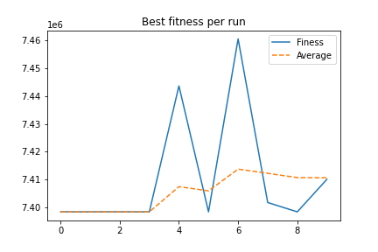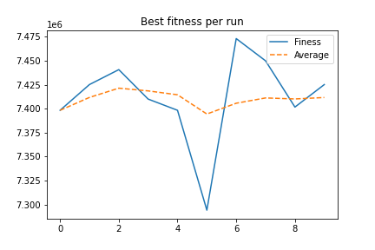
Image 2.5 Inst-16 run with 5% crossover Image 2.6 Inst-16 run with 30% crossover
Image 2.7 Inst-16 run with 80% crossover
Run | NN Best solution for 5% crossover | NN Iteration found for 5% | NN Best solution for 30% crossover | NN Iteration found 30% | NN Best solution for 80% crossover | NN Iteration found 80%
1 | 7398331.207 | 0 | 7398331.207 | 0 | 7331091.892 | 286
2 | 7398331.207 | 0 | 7425189.535 | 0 | 7228016.111 | 17
3 | 7398331.207 | 0 | 7440778.974 | 0 | 7389176.076 | 42
4 | 7398331.207 | 0 | 7410032.083 | 0 | 7279700.219 | 12
5 | 7443667.259 | 0 | 7398331.207 | 0 | 7362783.325 | 19
6 | 7398331.207 | 0 | 7294049.72 | 2 | 7184855.897 | 153
7 | 7460589.505 | 0 | 7473205.984 | 0 | 7221029.46 | 17
8 | 7401694.918 | 0 | 7449977.146 | 2 | 7347781.879 | 92
9 | 7398331.207 | 0 | 7401694.918 | 0 | 7305891.739 | 440
10 | 7410032.083 | 0 | 7425189.535 | 0 | 7389993.104 | 7
Avg. | 7410597.101 | 0 | 7411678.031 | 0.4 | 7304031.97 | 108.5
Table 2.1 – Best solutions and iterations it was found for different parameter

Table 2.1 above shows how the chance of early convergence increases when the Pc values are low for nearest neighbour insertions, which is down to the reduced combinations attempts and the fact that the initial population contains already strong solutions, as the current implementation is also using elitism and truncation selection it will bias, even more, the search towards a non-diverse group of individuals. As the crossover rate grows, more combinations will happen, and the chances of getting different individuals in the newer generation are higher.
It is also interesting to comment that there is very low impact for the execution time by tweaking these hyperparameters, and that is because to minimize the runtime impact of crossover in my implementation, the parent’s chromosomes are converted into dictionaries which will allow direct access to the indexes and reduce the cost of applying the changes required as there is no need for iterating through each of the genes twice.
I also opted for generating two children per crossover to avoid iterating N times through the population but only N/2, where N is the population size.
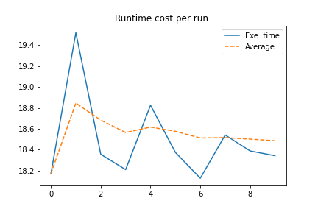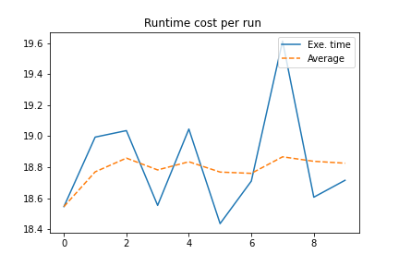
Image 2.8 Inst-16 runtime cost for 5% crossover Image 2.9 Inst-16 runtime cost with 30% crossover
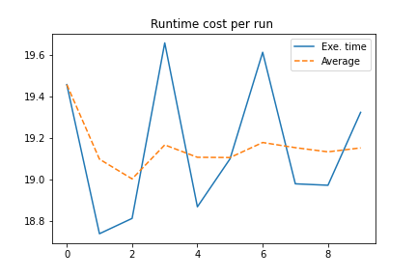
Image 2.10 Inst-16 runtime cost with 5% crossover in seconds
The table below provides details for the parameters used to run the experiments used in the comparisons presented here.
File | Crossover probability | Mutation probability | Iterations | Population size | Elitism | initialization
inst-16.tsp | 0.05 | 0.05 | 500 | 100 | 0.1 | 0
inst-16.tsp | 0.3 | 0.05 | 500 | 100 | 0.1 | 0
inst-16.tsp | 0.8 | 0.05 | 500 | 100 | 0.1 | 1
inst-16.tsp | 0.05 | 0.05 | 500 | 100 | 0.1 | 1
inst-16.tsp | 0.3 | 0.05 | 500 | 100 | 0.1 | 1
inst-16.tsp | 0.8 | 0.05 | 500 | 100 | 0.1 | 1
Table 2.3 – parameters for experiments ran

- Mutation impacts:
The mutation is the process responsible for inserting new information into the generation, leading to better solutions in some cases. Crossover, which we discussed previously, do not insert any further information into the new generations as it will only combine the parent’s genes to generate a new chromosome. That is one of the differences from mutation, which will get a slice of the genes and apply an operator to transform that slice into something else that can or not be beneficial for the individual fitness. For the experiments carried out for this report, the mutation operator used was the inversion operator, which will only invert the order of genes for a random slice and is considered one of the less disruptive operators. The mutation probabilities evaluated are 0.25%, 5% and 50%.

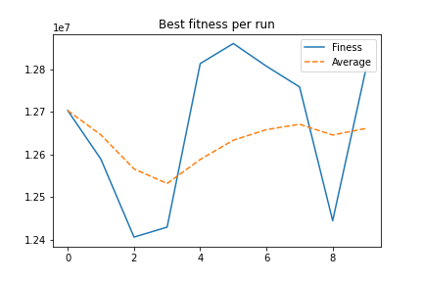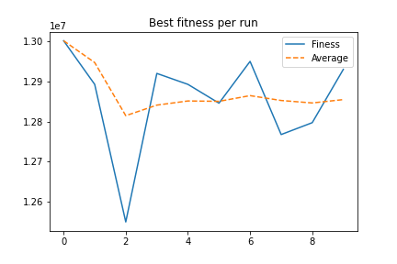
Image 3.0 Inst-6 runtime cost for 0.5% crossover Image 3.1 Inst-6 runtime cost for 5% crossover
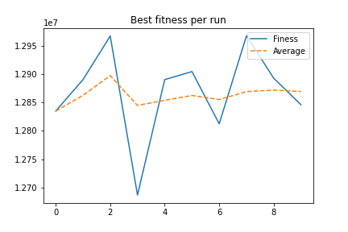
Image 3.2 Inst-6 runtime cost for 50% crossover

Run | Initial best | Best solution | Iteration found
1 | 12930169.68 | 12702708.64 | 415
2 | 12890328.34 | 12588625.42 | 19
3 | 12903951 | 12405756.94 | 156
4 | 12892859.59 | 12429004.77 | 1
5 | 12929887.24 | 12813055.66 | 18
6 | 12934249.41 | 12860081.64 | 19
7 | 12890328.34 | 12806794.26 | 54
8 | 12920107.55 | 12758206.78 | 63
9 | 12920107.55 | 12444284.84 | 50
10 | 12908737.27 | 12798785.79 | 472
Avg. | 12912072.6 | 12660730.47 | 126.7
Table 3.0 generated based on runs with inst-6.tsp with 0.5% Pm

Run | Initial best | Best solution | Iteration found
1 | 13118930.04 | 13001535.15 | 24
2 | 12892859.59 | 12892859.59 | 0
3 | 12935406.66 | 12550071.76 | 12
4 | 12920107.55 | 12920107.55 | 0
5 | 12892859.59 | 12892859.59 | 0
6 | 12892859.59 | 12845998.15 | 3
7 | 12958912.04 | 12950123.13 | 16
8 | 12892859.59 | 12767839.95 | 7
9 | 12903951 | 12797405.79 | 84
10 | 12930169.68 | 12930169.68 | 0
Avg. | 12933891.54 | 12854897.04 | 14.6
Table 3.1 generated based on runs with inst-6.tsp with 5% Pm

Run | Initial best | Best solution | Iteration found
1 | 12929887.24 | 12834914.32 | 2
2 | 12890328.34 | 12890328.34 | 0
3 | 12967126.87 | 12967126.87 | 0
4 | 12890328.34 | 12686831.66 | 1
5 | 12890328.34 | 12890328.34 | 0
6 | 12904480.64 | 12904480.64 | 0
7 | 12967126.87 | 12812406.7 | 1
8 | 13016703.7 | 12967574.2 | 3
9 | 12892859.59 | 12892859.59 | 0
10 | 12944719.93 | 12846073.36 | 2
Avg. | 12929388.98 | 12869292.4 | 0.9
Table 3.2 generated based on runs with inst-6.tsp with 50% Pm

The images and tables above show how the increase of mutation rates will also increase the chances of early convergence; for a 0.5% mutation rate, the average convergence generation was 126 iterations which then decreased to 14.6 with 5% and eventually to 0.9 with 50%. The main reason is that mutation will insert new information, swapped sequence of cities since TSP is a permutation problem, which sometimes can be beneficial, but when the mutation rate is too high cause more disruption than actually help in the search. Good information that already exists in the chromosomes can be lost then.
In terms of runtime cost, the mutation has a low impact on execution time since it only slices a part of the chromosome and inserts it again in the inverse order; the images below show the slight difference in runtime experience for the runs with 0.5%, 5% and 50%.
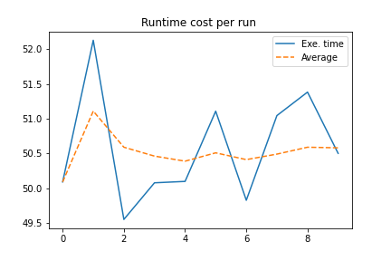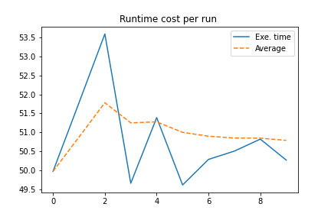
Image 3.3 Inst-6 runtime cost for 0.5% mutation Image 3.4 Inst-6 runtime cost for 5% mutation

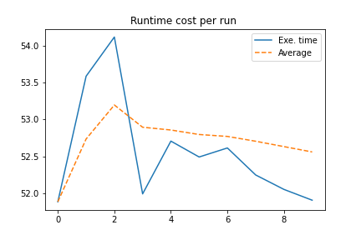
Image 3.5 Inst-6 runtime cost for 50% mutation

The table below provides details for the parameters used to run the experiments used in the comparisons presented.
File | Crossover probability | Mutation probability | Iterations | Population size | Elitism | initialization
inst-6.tsp | 0.8 | 0.005 | 500 | 100 | 0.1 | 1
inst-6.tsp | 0.8 | 0.05 | 500 | 100 | 0.1 | 1
inst-6.tsp | 0.8 | 0.5 | 500 | 100 | 0.1 | 1

Table 3.3 – parameters for experiments ran

- Elitism impacts:
Elitism will keep the fittest individuals from the previous generation in the new population to be picked for crossover, provided they are within the 25% best in the new generation that will make it to the mating pool.
There are different approaches to implement elitism; for this report, we take the top x items from the previous generation, the bottom x from the new one and select only the best within this group. That was my choice to ensure only the actual fittest individuals are taken without reducing the number of crossover mutations we can have within each iteration. Another approach would be generating only P-x of the population as new children and taking the top 10% from the previous one. That would have some gain in terms of execution time but does not ensure that the top 10% fittest is better than the 10% that would be generated. A crossover or mutation for the x we will not go through could result in a better solution than that 10% in the past generation.

Run | Initial best | Best solution | Iteration found
1 | 3908620.311 | 3908620.311 | 0
2 | 3885429.235 | 3852340.598 | 461
3 | 3885429.235 | 3869591.588 | 395
4 | 3900881.29 | 3900881.29 | 0
5 | 3885429.235 | 3885429.235 | 0
6 | 3900881.29 | 3898922.925 | 2
7 | 3885429.235 | 3885429.235 | 0
8 | 3900881.29 | 3900881.29 | 0
9 | 3933557.768 | 3932788.84 | 41
10 | 3933557.768 | 3921584.884 | 6
Avg. | 3902009.665 | 3895647.02 | 90.5
Table 4.0 inst-4 with elitism

Run | Initial best | Best solution | Iteration found
1 | 3885429.235 | 3810301.076 | 407
2 | 3908620.311 | 3888851.126 | 199
3 | 3885429.235 | 3885429.235 | 9
4 | 3900881.29 | 3820957.39 | 119
5 | 3943128.07 | 3889460.342 | 454
6 | 3885429.235 | 3846608.223 | 349
7 | 3885429.235 | 3872785.396 | 166
8 | 3885429.235 | 3856989.292 | 3
9 | 3908620.311 | 3848048.034 | 400
10 | 3885429.235 | 3885429.235 | 0
Avg. | 3897382.539 | 3860485.935 | 210.6
Table 4.1 inst-4 without elitism

On average, without elitism, we get better results due to the diversity in the generations; the first generation for the runs shown in the tables above was initiated with the nearest neighbour insertion. Naturally, it already has strong individuals on it. Applying elitism will decrease the diversity by making sure the 10% stronger from past generations will always be taken to the next generation. Diversity is essential for genetic algorithms to avoid premature convergence to local optima.

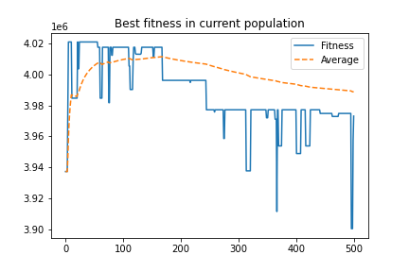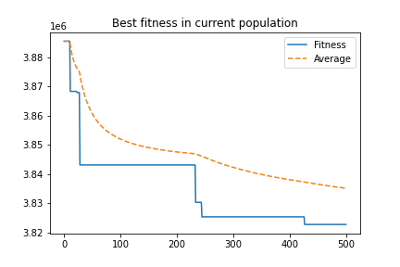
Image 4.0 Inst-4 best per population without elitism Image 4.1 Inst-4 best per population with elitism
Images 4.0 and 4.1 show the difference between best fitness in the population for a run without elitism and another with elitism respectively. Image 4.0 shows that the best fitness goes up and down depending on the generation. In contrast, 4.1 show elitism makes it more constant, only going down when a fitter child appears. The main reason for this is that the fittest will always live across generations.
Regarding the runtime cost, only a few seconds per run were noticed between both approaches.
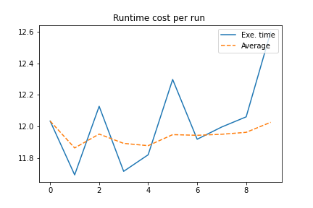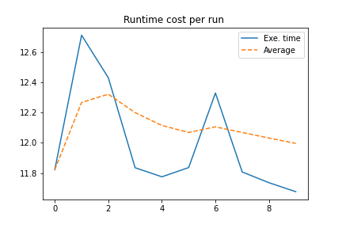
Image 4.1 Inst-4 best per pop. Without elitism, in seconds Image 4.2 Inst-4 best per pop. with elitism in seconds

The table below provides details for the parameters used to run the experiments in the comparisons presented.
File | Crossover probability | Mutation probability | Iterations | Population size | Elitism | initialization
inst-4.tsp | 0.8 | 0.05 | 500 | 100 | 0.0 | 1
inst-4.tsp | 0.8 | 0.05 | 500 | 100 | 0.1 | 1
Table 4.2 – parameters for experiments ran

- Population size impacts:
The population size is an excellent parameter to update to fight against some of the issues related to early convergence we have seen on previous runs. A larger population will have more candidates to crossover and mutation and more chances of generating better individuals. This report will analyze the performance (quality of results and runtime ) for three different population sizes 10, 100, and 1000.

Run | Initial best | Best solution | Iteration found
1 | 13184545.93 | 12758794.97 | 1
2 | 13182409.39 | 13182409.39 | 0
3 | 12920107.55 | 12920107.55 | 0
4 | 13193585.5 | 13193585.5 | 0
5 | 13040662.48 | 13040662.48 | 0
6 | 13135165.25 | 13135165.25 | 0
7 | 13177692.85 | 13177692.85 | 0
8 | 13177692.85 | 12908737.27 | 0
9 | 13285666.87 | 13285666.87 | 0
10 | 13069016.16 | 13069016.16 | 0
Avg. | 13136654.48 | 13067183.83 | 0.1
Table 5.0 – initial and best solutions for a run with inst-6 pop. Size 10

Run | Initial best | Best solution | Iteration found
1 | 12920107.55 | 12848606.14 | 9
2 | 12908737.27 | 12908737.27 | 0
3 | 12926307.73 | 12831358.16 | 4
4 | 12909894.7 | 12496983.09 | 23
5 | 12890328.34 | 12773587.57 | 19
6 | 12908737.27 | 12908737.27 | 0
7 | 12890328.34 | 12791345.95 | 12
8 | 12908737.27 | 12794636.04 | 3
9 | 12942802.15 | 12821644.46 | 2
10 | 12951692.69 | 12700246.21 | 10
Avg. | 12915767.33 | 12787588.22 | 8.2
Table 5.1 – initial and best solutions for a run with inst-6 pop. Size 100

Run | Initial best | Best solution | Iteration found
1 | 12890328.34 | 12315088.94 | 18
2 | 12890328.34 | 12356719.53 | 456
3 | 12892859.59 | 12406911.11 | 485
4 | 12892859.59 | 12463337.08 | 29
5 | 12890328.34 | 12259648.66 | 319
6 | 12890328.34 | 12162542.38 | 486
7 | 12890328.34 | 12241329.36 | 230
8 | 12890328.34 | 12227602.05 | 499
9 | 12890328.34 | 12341314.39 | 34
10 | 12892859.59 | 12242376.75 | 239
Avg. | 12891087.71 | 12301687.02 | 279.5
Table 5.1 – initial and best solutions for a run with inst-6 pop. Size 1000

Note that the following images below depict the best individuals per generation without considering the elite brought over from the previous generation.
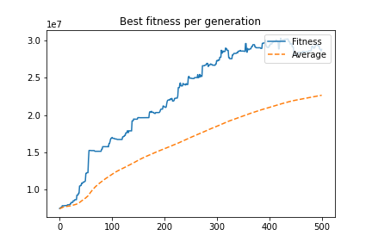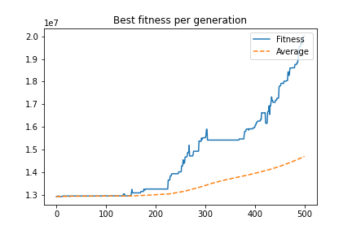
Image 5.0 Inst-6 best per gen pop. Size 10 Image 5.1 Inst-6 best per gen pop. size 100

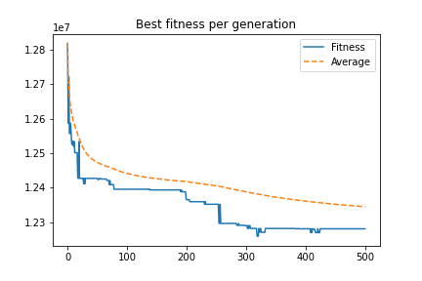
Image 5.2 Inst-6 best per gen pop. size 1000
Table 3.0 shows that results for only ten individuals in the population have a terrible performance when it comes to improvements in the tour distance. That is because the number of individuals is too low, consequently getting uniform straight away, it is much easier for a super individual to take over in a small population. Image 3.0 shows how the algorithm converges after the first generation, and it cannot find any other fitter individual from there. There are visible improvements when the population increases to 100, and the algorithm converges only around generation 120. Table 3.3 shows even better results for 1000 individuals with a lower best fitness average compared to the initial average; in image 3.3, we can see the algorithm is constantly able to find better solutions and avoid convergence with the larger population value.
Note that larger populations also have bigger chances of containing different individuals within it and hence more diversity. With time, the individuals may get more uniform if a super individual takes over; however, it will take more time than in a smaller population.
However, larger populations will also increase the computation time required to go through all the generations since we will have a more significant number of individuals to compute fitness for.
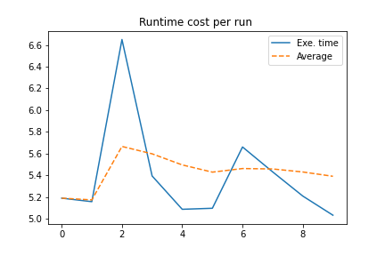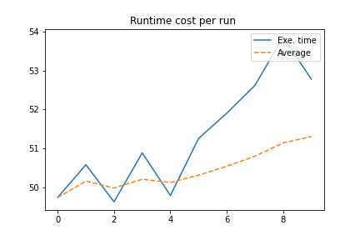
Image 5.0 Inst-6 runtime cost pop. size 10 Image 5.1 Inst-6 runtime cost pop. size 100

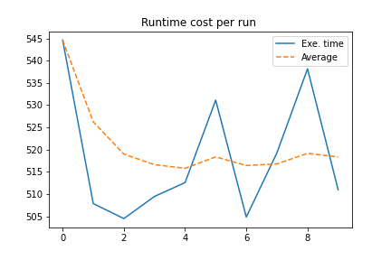
Image 5.2 Inst-6 runtime cost pop. size 1000

As shown in the images above, the run time cost grows proportionally with the population size. Witch is down to how the algorithm iterates through the population multiple times to generate the offspring and new populations.
The table below provides details for the parameters used to run the experiments that were used in the comparisons presented.
File | Crossover probabiity | Mutation probabbility | Iterations | Population size | Elitism | initialization
inst-6.tsp | 0.8 | 0.05 | 500 | 10 | 0.1 | 1
inst-6.tsp | 0.8 | 0.05 | 500 | 100 | 0.1 | 1
inst-6.tsp | 0.8 | 0.05 | 500 | 1000 | 0.1 | 1
Table 5.2 – parameters for experiments ran

- Conclusion:
Genetic algorithms are a powerful technique for some types of problems; it requires a lot of experimentation and fine-tuning to find the correct hyperparameter, but once the parameters are set correctly, it is possible to get excellent results with it.

